- CLASS AND OBJECT

AIM:

To create a class program and object in c++.

ALGORITHM:
· Include the header file <iostream> for input and output operations.
· Use the standard namespace std.
· Define a class named Student.
· Declare age as an integer data member inside the class.
· Declare name as a string data member inside the class.
· Begin the main() function.
· Declare an object S1 of the class Student.
· Assign the value 20 to the data member age of object S1.
· Assign the value "MUTHUGANESH S" to the data member name of object S1.
· Display the value of age using the output statement.
· Display the value of name using the output statement.
PROGRAM:

/*
Program to demonstrate a simple class in C++
Author : MUTHUGANESH S
Date : 21/1/2026
Filename: ClassProgram.cpp
retval : void
*/

#include <iostream>
using namespace std;

// Class Declaration
class Student{
public:
//Members Variables
int age;
string name;
};

// Main Function
int main(void) {

// Object Declaration
Student S1;

// Assigning values to member variables
S1.age = 20;
S1.name = "MUTHUGANESH S";

// Displaying values
cout << "Age : "<< S1.age <<"\nName : "<< S1.name << endl;

return 0;
}

OUTPUT:

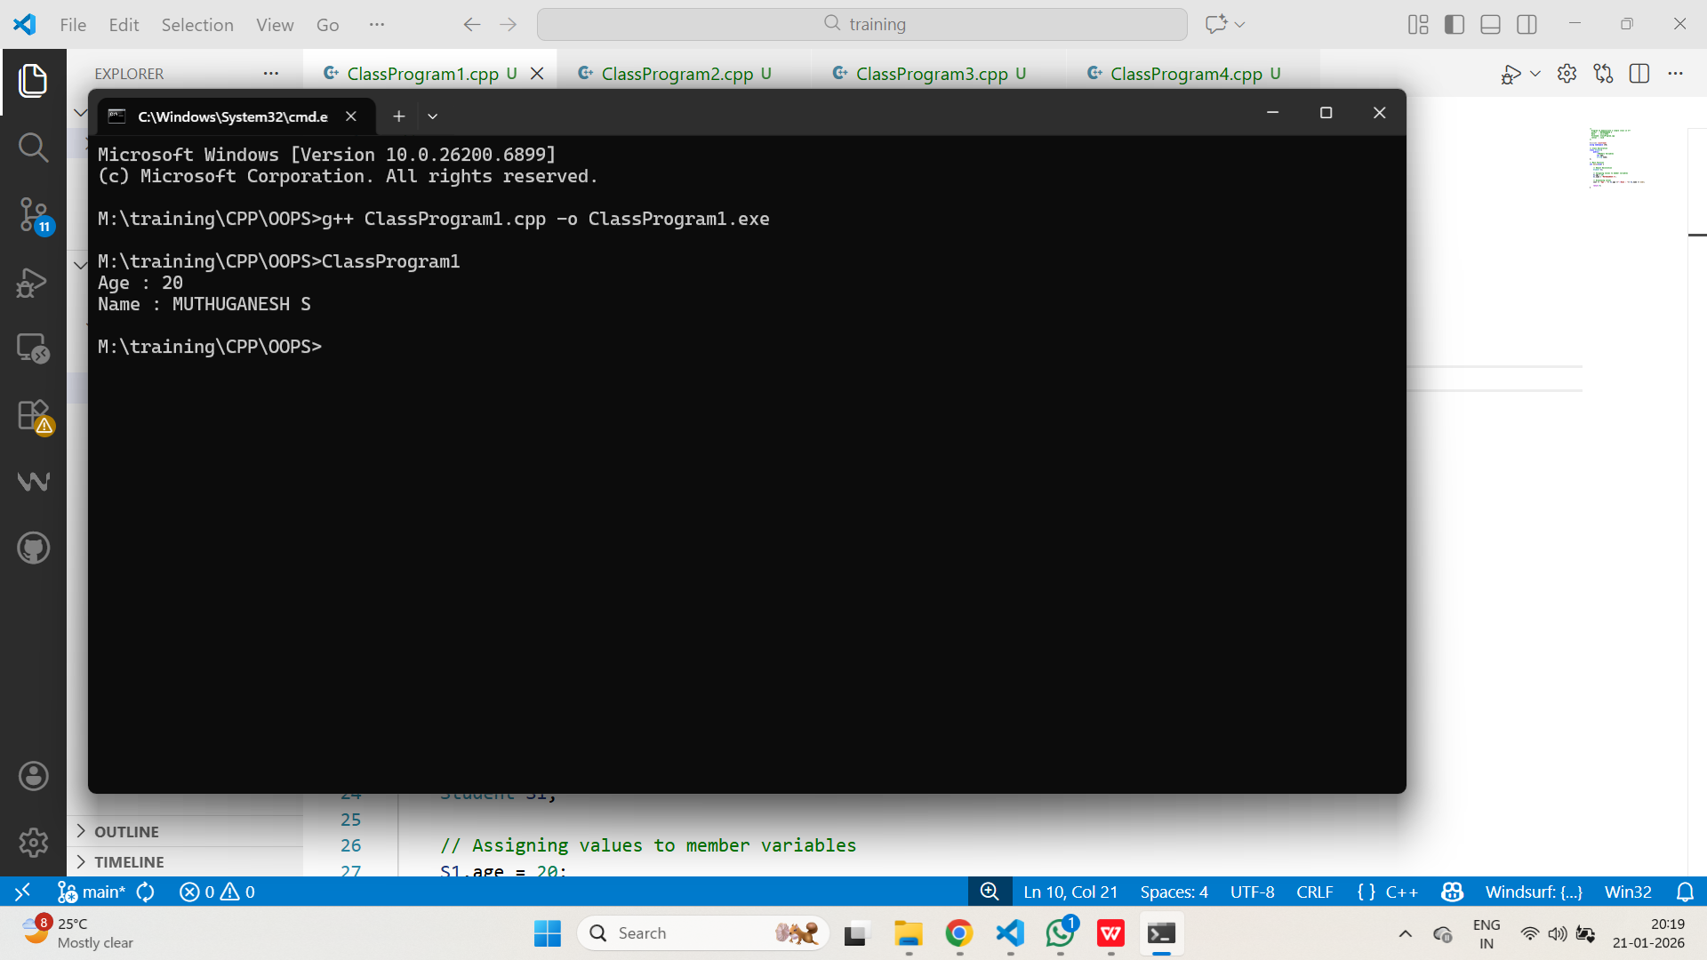

- ACCESS SPECIFIER
AIM:

To create Class and object in C++ program using Access specifier.

ALGORITHM:
· Include the header file <iostream> for input and output operations.
· Use the standard namespace std.
· Define a class named Student.
· Declare private data members Age and Name inside the class.
· Declare the member function setDetails() to assign values to Age and Name.
· Declare the member function display() to print the values of Age and Name.
· Begin the main() function.
· Declare an object S1 of the class Student.
· Call the member function setDetails() using object S1 to assign values.
· Call the member function display() using object S1 to display the values.

PROGRAM:

/*
* Program to demonstrate the use of classes and Pointer to Object in C++
* Author : MUTHUGANESH S
* Date : 21/1/2026
* Filename: ClassProgram3.cpp
* retval : void
*/

#include <iostream>
using namespace std;

// Class Declaration
class Student {
public:
int age;
string name;
void setDetails(int age, string name) {
this->age = age;
this->name = name;
}
void display() {
cout << "Age : "<< age <<"\nName : "<< name << endl;
}
};

// Main Function
int main(void) {

// Object Declaration
Student S1;

// Pointer to Object
Student *ptr;

// Assigning address of S1 to ptr
ptr = &S1;

// Using pointer to set values
ptr->setDetails(20, "MUTHUGANESH S");

// Using pointer to display values
cout<< "Using Pointer to Object:\n";
ptr->display();

cout<< "\nUsing Object Directly:\n";
S1.display(); // Directly using object to display values

return 0;
}

OUTPUT:

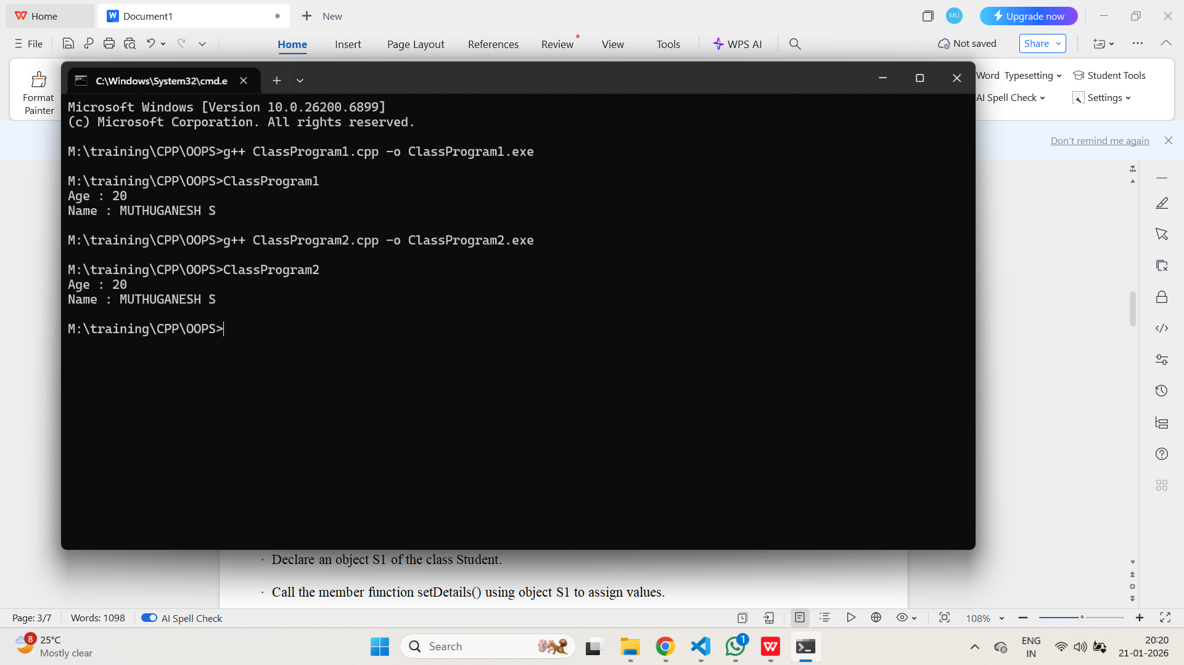

- OBJECT REFERENCE
AIM:

To create a Class and Object and also Object pointer.

ALGORITHM:
· Include the header file <iostream> for input and output operations.
· Use the standard namespace std.
· Define a class named Student.
· Declare public data members age and name inside the class.
· Define the member function setDetails() to assign values using the this pointer.
· Define the member function display() to print the values of age and name.
· Begin the main() function.
· Declare an object S1 of the class Student.
· Declare a pointer ptr to the class Student.
· Assign the address of object S1 to the pointer ptr.
· Call the member function setDetails() using the pointer ptr.
· Display a message indicating the use of pointer to object.
· Call the member function display() using the pointer ptr.
· Display a message indicating direct object access.
· Call the member function display() using the object S1.
· Return 0 to terminate the program.

PROGRAM:

/*
* Program to demonstrate the use of classes and Pointer to Object in C++
* Author : MUTHUGANESH S
* Date : 21/1/2026
* Filename: ClassProgram3.cpp
* retval : void
*/

#include <iostream>
using namespace std;

// Class Declaration
class Student {
public:
int age;
string name;
void setDetails(int age, string name) {
this->age = age;
this->name = name;
}
void display() {
cout << "Age : "<< age <<"\nName : "<< name << endl;
}
};

// Main Function
int main(void) {

// Object Declaration
Student S1;

// Pointer to Object
Student *ptr;

// Assigning address of S1 to ptr
ptr = &S1;

// Using pointer to set values
ptr->setDetails(20, "MUTHUGANESH S");

// Using pointer to display values
cout<< "Using Pointer to Object:\n";
ptr->display();

cout<< "\nUsing Object Directly:\n";
S1.display(); // Directly using object to display values

return 0;
}

OUTPUT:

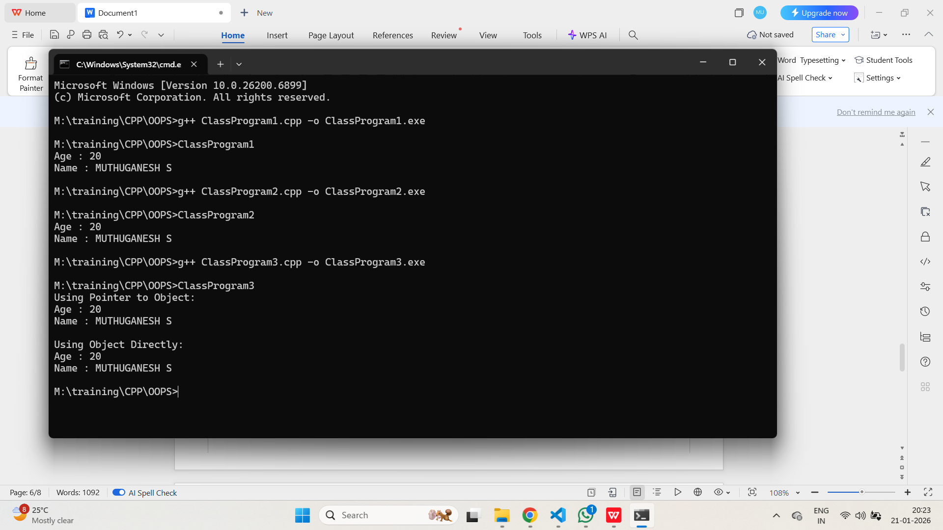

- MULTIPLE OBJECT
AIM:

To create a class and multiple objects for same class.

ALGORITHM:
· Include the header file <iostream> for input and output operations.
· Use the standard namespace std.
· Define a class named Student.
· Declare public data members age and name inside the class.
· Define the member function setDetails() to assign values to age and name.
· Define the member function display() to print the values of age and name.
· Begin the main() function.
· Declare three objects S1, S2, and S3 of the class Student.
· Call the member function setDetails() for object S1 to assign values.
· Call the member function setDetails() for object S2 to assign values.
· Call the member function setDetails() for object S3 to assign values.
· Display a heading for Student 1 details.
· Call the member function display() for object S1.
· Display a heading for Student 2 details.
· Call the member function display() for object S2.
· Display a heading for Student 3 details.
· Call the member function display() for object S3.

PROGRAM:

/*
* Program to demonstrate the use of classes and multiple objects in C++
* Author : MUTHUGANESH S
* Date : 21/1/2026
* Filename: ClassProgram4.cpp
* retval : void
*/

#include <iostream>
using namespace std;

// Class Declaration
class Student {
public:
int age;
string name;
void setDetails(int age, string name) {
this->age = age;
this->name = name;
}
void display() {
cout << "Age : "<< age <<"\nName : "<< name << endl;
}
};

int main(void) {
// Object Declaration
Student S1, S2, S3;

// Assigning values to member variables
S1.setDetails(20, "MUTHUGANESH S");
S2.setDetails(21, "Magesh K");
S3.setDetails(22, "Yogesh L");

// Displaying values
cout<< "Details of Student 1:\n";
S1.display();
cout<< "Details of Student 2:\n";
S2.display();
cout<< "Details of Student 3:\n";
S3.display();

return 0;
}

OUTPUT:

